L1 #general

Sit on hoop flip (hoop)

Execution judge
Common execution errors to look for:
- Hit the gymnast’s body by accident or get stuck

Training Progression
- Knees must be apart. Then experiment the correct hoop placement position – somewhere a little further down from behind the knees. Assist with arms once motion is originated.

Side to side twist step (hoop, rope)

Execution judge
Common execution errors to look for:
- Legs or knees drifting apart or not shifting together
- Arms not relatively straight

Training Progression
Focus in on heel toe. Make sure knees and foot are locked and use the hip to originate the side ways twist.
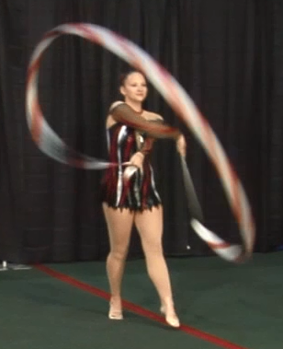
Figure 8 while hanging onto end of ribbon (ribbon)

Execution judge
Common execution errors to look for:
- Ribbons tangled up
- Arms not relatively straight

Training Progression
Isolate left and right hand. Right hand do big figure 8 on the sides. Left hand goes right as right arm goes left.

