L2 hoop passé hops

Difficulty judge

Start (0.2)
- Raise hoop and extend arms
- Look down at hoop when hoop swings down

Element (0.5)
- Should have enough lift to straighten out bottom leg and point toes
- Hoop and arms must be on correct side plane
- Hoop and arms on swing down must pass the body substantially
- Passe shape must be evident with thigh close to parallel and toes pointed towards support knee
- Hoop should be high up on the hop and step on swing down

Finish (0.2)
- Controlled landing for each of the hop landing

Bonus (0.1)

Execution judge
Common execution errors to look for:
- Coil / hunch of the body because of lack of flexibility
- Bottom leg bent because of lack of height
- Improper grabbing of the hoop
- Arms not fully extended

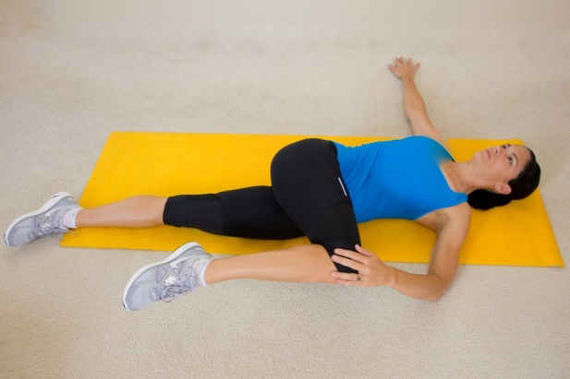
Training Progression
- The element requires crossover flexibility of hip/waist. One example of a possible stretch. Watch out for bottom leg bending. Emphasize on body, shoulder, hip and chest opening/extension. (Practice also with both arms crossed over as well).
- Practice step hop so that there is enough power to lift entire body up. Emphasize on ‘speed change’ to give power and not tensing up more or just say ‘higher’.

