L3 Ribbon D3 steps over frontal circles

Difficulty judge

Start (0.2)
- Big arm circles in the frontal plane with feet together

Element (0.5)
- Step over and through forward with big arm circles in front

Finish (0.2)
- Legs together with arms in front spirals

Bonus (0.1)

Execution judge
Common execution errors to look for:
- Imprecise plane of frontal circles
- Imprecise shape of each step
- Stepped on or tangled the ribbon during step

Training Progression
- Learn the steps first as in coaching video.
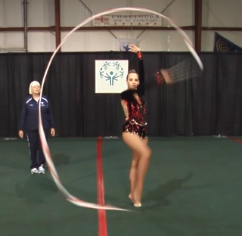
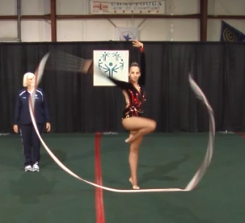
- Do the step with ribbon. Timing: Tuck knee up when ribbon circling down. Timing is to prepare to step forward when arms up and put foot down as the tail has passed (or almost) the front.

