SETUP NOTES FOR KILLARNEY:
Set up team should be arrive at least 15 minutes prior to gym available (7:45AM) to make sure everyone knows who is doing, keys for the dividers, gain access to tables and chairs, etc.
Tools required:
- Sometimes measuring tape is required but for zone we will simply use the carpet area as in bound.
- Need to use duct tapes to pin down seems between competition carpet. (13M long X 3 for each set up).
- Vacuum cleaner for the competition carpet.
- Arch and decoration of the entrance onto competition floor.
- Tablecloth for judges table, music and awards.
- Speaker wires. (Borrowed from Sound Great).
- Masking tape or big sheet of paper for ordering music.
- Some decorations where possible. (e.g. arch from UBC).
- Toolbox for setting up the arch (probably screw drivers, duct tape, and scissors/knife for cutting tapes).
- Two extension cords for vacuum cleaner before the competition, for music and for the computer and printer (will need one power bar).
Set up in priority sequence:
- Make sure the big divider separate out two gym. (Make sure there is a gap to run the speaker wires.
- Get the warm up area set up first. Gymnasts can help too.
- Get custodian to give us access to tables and chairs.
- No line judges. Set up enough table space for 8-9 persons at the judging table. Usually two long table is enough with the table gap at the centre line (green line of Killarney gym).
- Set up music table and music (get boom box from office). Test music.
- Set up competition carpet with centre at the judges’ table.
- Tape down competition carpet – esp. the seams between carpets.
- Set up audience chairs. Allow space for walking space behind the audience for access to the other side of gym.
- Set up award table.
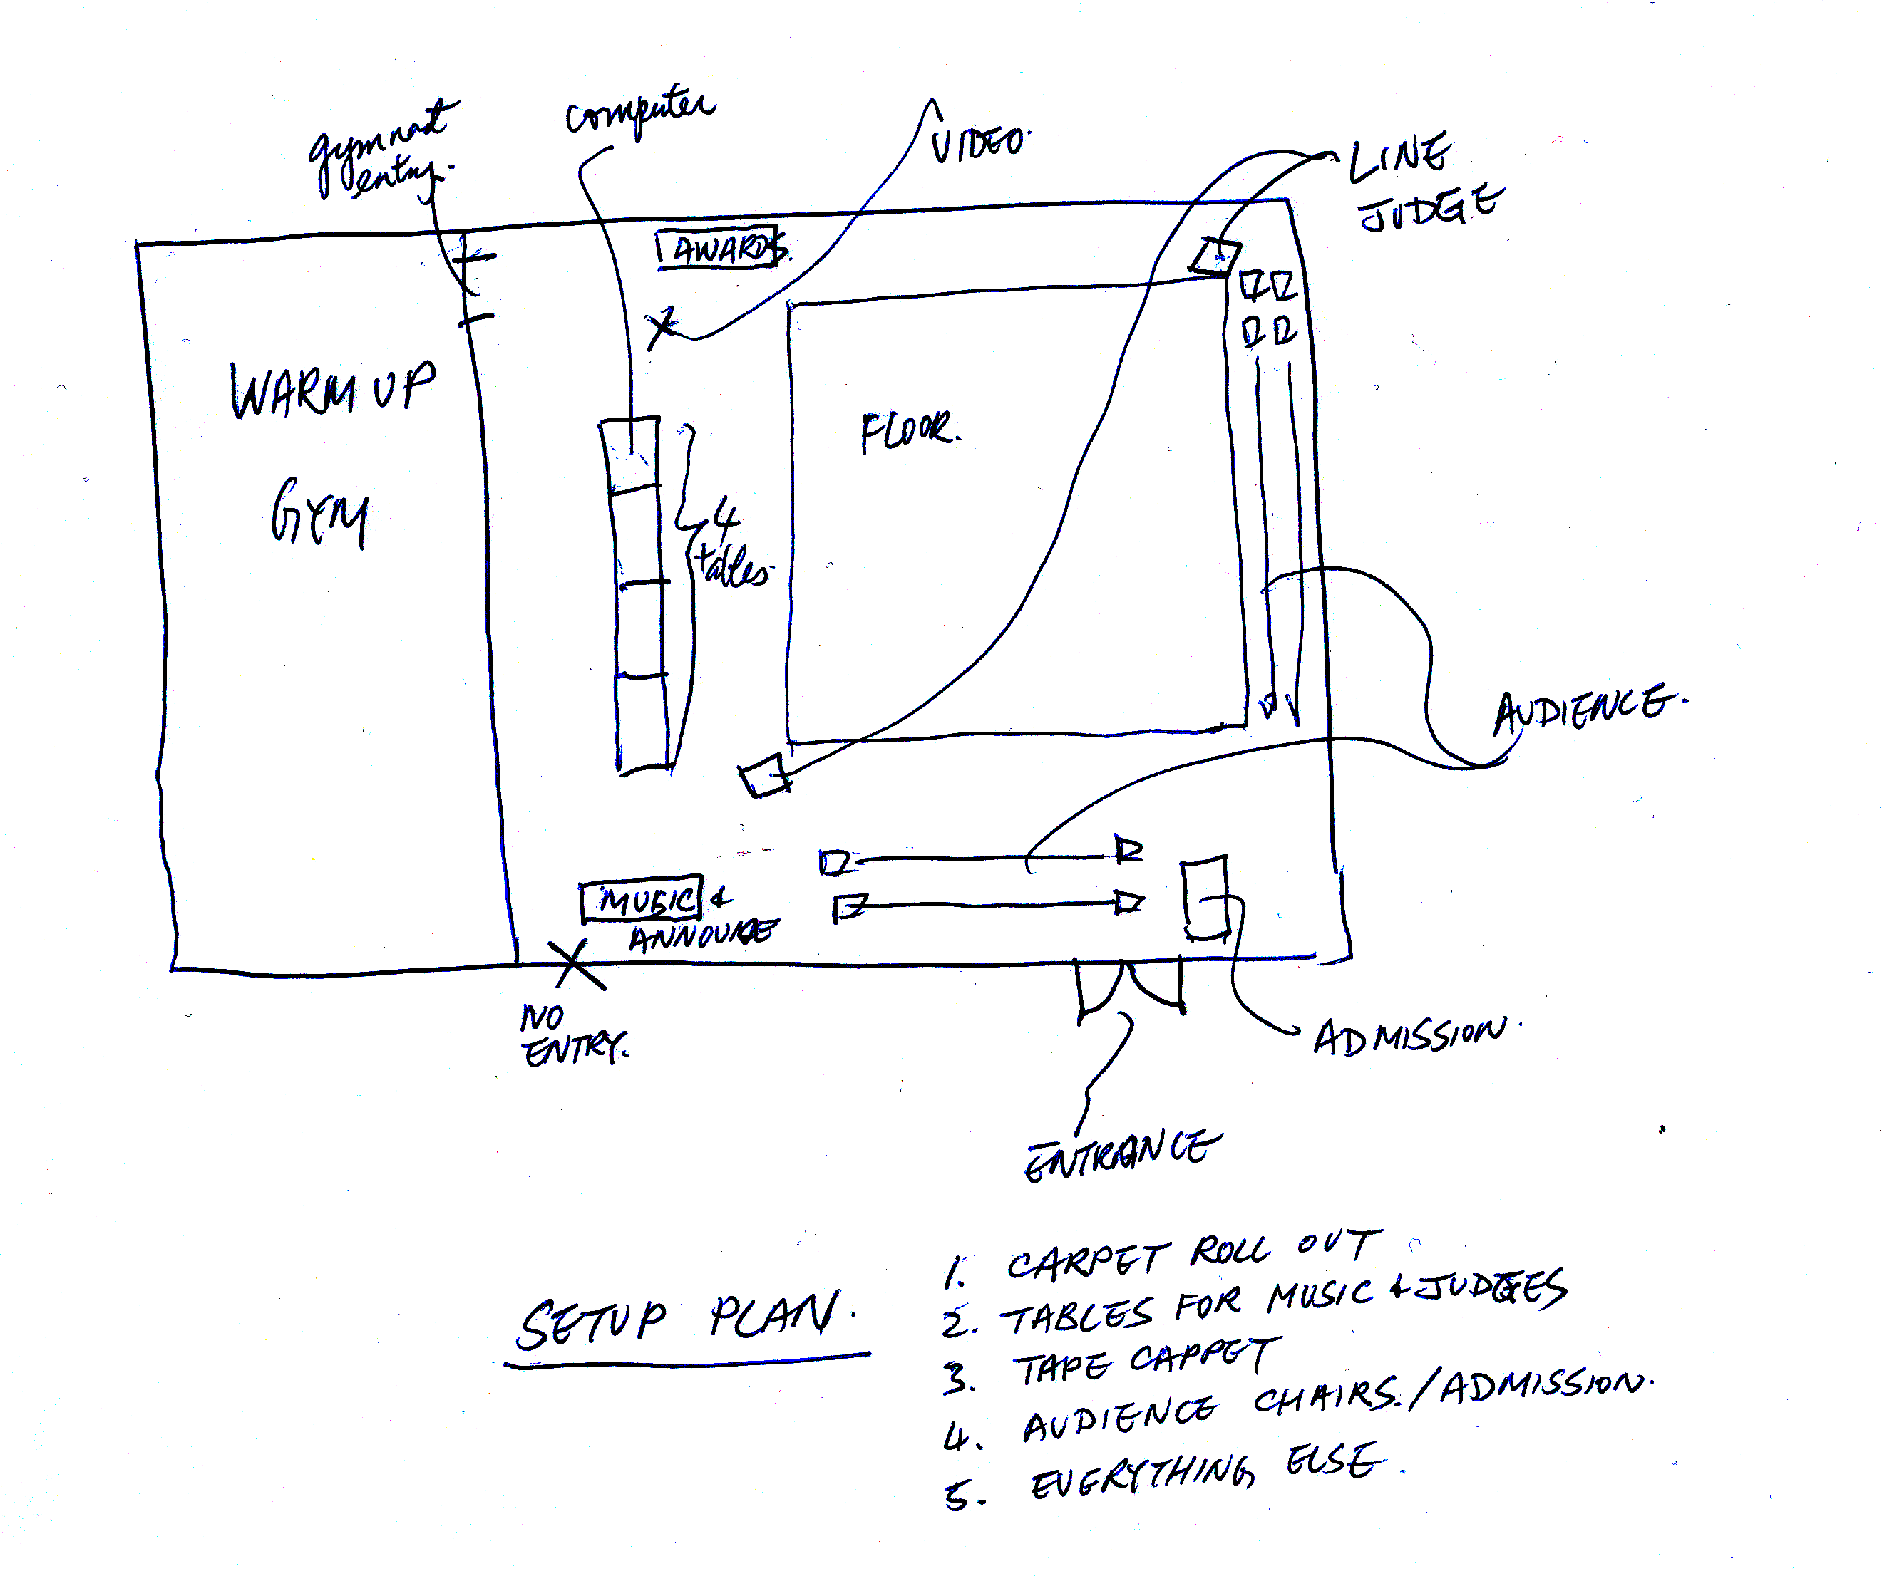
- Tape down wires where people may trip using non-residual tapes. Especially across the entrance way.

